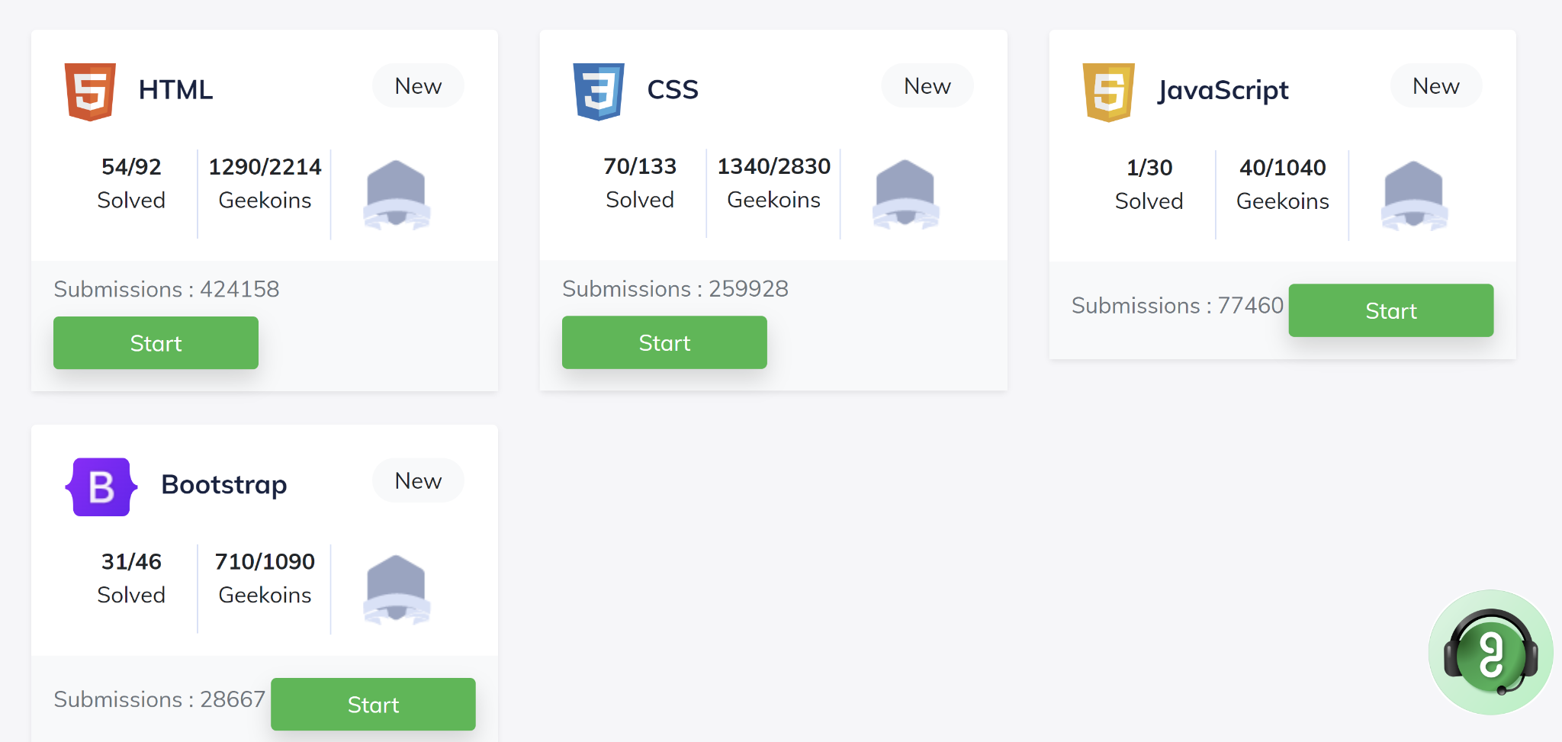

HTML-19

CSS-25

Bootstrap-11

Total -55